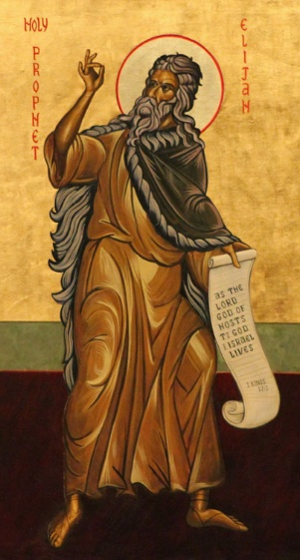
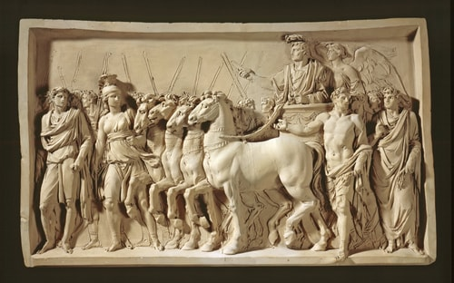
Mark 1:1-8
The beginning of the good news^{[a]} of Jesus Christ.

² As it is written in the prophet Isaiah,
“See, I am sending my messenger ahead of you,
who will prepare your way,
³ the voice of one crying out in the wilderness:
‘Prepare the way of the Lord;
make his paths straight,’ ”

⁴ so John the baptizer appeared in the wilderness, proclaiming a baptism of repentance for the forgiveness of sins. ⁵ And the whole Judean region and all the people of Jerusalem were going out to him and were baptized by him in the River Jordan, confessing their sins. ⁶ Now John was clothed with camel’s hair, with a leather belt around his waist, and he ate locusts and wild honey. ⁷ He proclaimed, “The one who is more powerful than I is coming after me; I am not worthy to stoop down and untie the strap of his sandals. ⁸ I have baptized you with^{[f]} water, but he will baptize you with^{[g]} the Holy Spirit.”

Malachi 4:5 “See, I will send you the prophet Elijah before the great and terrible day of the Lord comes.”
Second Sunday of Advent: John announces the good news of the Lord Jesus & return from exile
Malachi 3:1 “See, I am sending my messenger to prepare the way before me, and the Lord whom you seek will suddenly come to his temple. The messenger of the covenant in whom you delight—indeed, he is coming, says the Lord of hosts.”
2 Kings 1:8 They answered him, “A hairy man with a leather belt around his waist.” He said, “It is Elijah the Tishbite.”
The beginning of the good news of Jesus Christ… just as it is written in Isaiah the prophet.
Isaiah 40:3 in Mark 1:3
Isaiah 6:9-10 in Mark 4:12
Isaiah 29:13 in Mark 7:6-7
Isaiah 56:7 in Mark 11:17
Isaiah 45:21 in Mark 12:32
Exodus 4x
Deuteronomy 8x
Psalms 5x

